

**T R O O P 2 9 1**

**North Florida Council**

**PVUMC/Our Lady Star of the Sea**

**Ponte Vedra Beach, FL**

**Eagle Scout**

**Court of Honor**

**For Marina Mitchell**

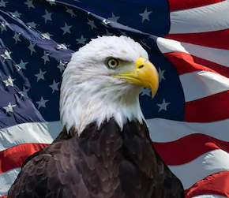

**___________________________________**

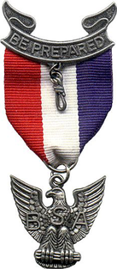

An Eagle Mom's Poem

It's every mother's dream to see,  
her children growing tall and strong.  
To teach them what is good and right   
but also keep them from the wrong.  
  
Mom so loves those little kids of hers  
and uses all the skills she can.  
She reminds them to always be Courteous and Kind

And always lend a helping hand.

.  
They learn that words can hurt or heal,  
that words can change the way we feel.  
They learn that truth is right and good

and to treat their fellow man the way they should.  
  
They learned that with great Freedom in this world,

there also stands their Nation's flag unfurled.  
They learn to live by Faith and Love,  
to always trust in God above.  
  
The years have passed and in their wake,  
 a taller, straighter Scout now stands.  
And Mother's pride is great indeed,  
her children now will know no need.  
  
Congratulations Eagle Scout,  
The world is wide and so spread out,  
Scouts taught you much of what life's about.  
Prepared you well for the life you’ve led,

May you grow, prosper and always look ahead.

**BOY SCOUT OATH**



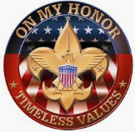

Thank you for attending

#### **On my honor I will do my best to do my duty to God and my country and to obey the Scout Law; to help other people at all times; to keep myself physically strong, mentally awake, and morally straight.**

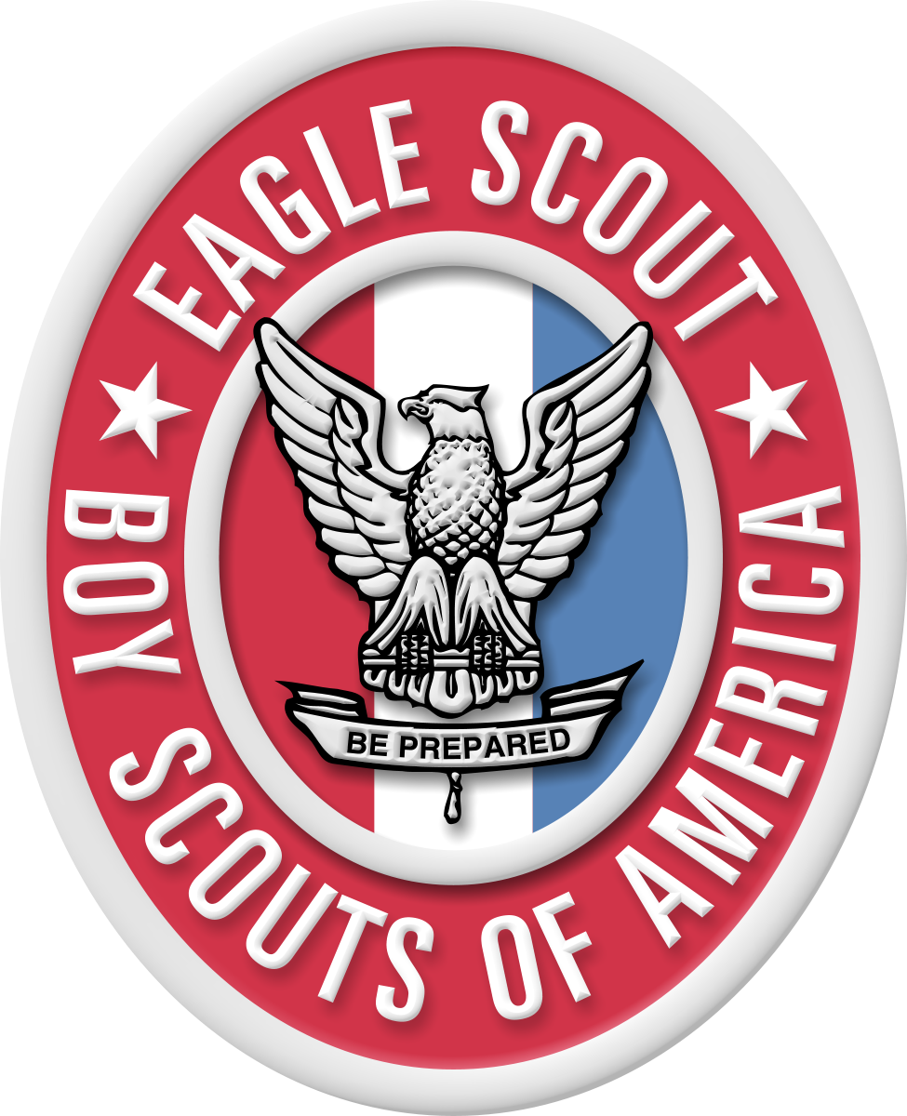



Leadership Roles:

Special Awards:

Rank Advancements:

Merit Badges earned: 23

Scout 02/22/19

Tenderfoot 03/07/19

Second Class 05/02/19

First Class 08/15/19

Star 12/14/19

Life 06/15/20

Eagle 02/02/21

Scribe 08/13/20 - 02/11/21

Troop Guide 02/14/20 - 08/13/20

Senior Patrol Leader 08/15/19 - 02/13/20 Assistant SPL 02/01/19 - 08/15/19

Animation 12/29/20, Cooking* 11/05/20, Kayaking 06/21/19, Art 07/02/19 ,Emergency Preparedness* 12/14/19, Personal Fitness* 02/06/20, Camping* 01/04/21, Environmental Science* 01/04/21, Personal Management* 08/19/20, Citizenship In Community* 08/23/20, Family Life* 11/04/19, Pottery 07/02/19 ,Citizenship In Nation* 02/24/20, Fingerprinting 06/18/20, Rifle Shooting 05/16/19, Citizenship In World* 05/21/20, First Aid* 12/10/19, Sculpture 08/04/19, Coin Collecting 09/01/19, Game Design 06/21/19, Swimming* 04/07/19, Communication* 07/09/20, Horsemanship 06/21/19.

* Eagle Merit Badge

2019 JTE Award 02/07/20, Ft Clinch Historic Hike 05/05/19, Ad Altare Dei: Catholic Emblem 01/31/20, NOA Camping Gold 01/04/21, Camp-wide Flags, Woodruff 06/19/19, NRA Marksman, Rifle 12/14/19, Cyber Chip 02/22/19, NRA Pro Marksman, Rifle 03/09/19, Davis Inn Hike, Woodruff 06/21/19, St Augustine Historic Hike 12/12/20, eXtreme Obstacle Course 03/09/19, Totin' Chip 02/23/19, Firem'n Chit 03/10/19, Whitewater Rafting 06/20/19, Founder 2/1/19

**Order of the Arrow:** Ordeal: 9/28/19



Scout Law:

A Scout is Trustworthy, Loyal, Helpful, Friendly, Courteous, Kind, Obedient, Cheerful Thrifty, Brave,

Clean & Reverent



Thank you to all the dedicated Leaders, Scouts, Family & Friends that have been part of Marina’’s journey to Eagle.

You have help build a lifetime of memories and help create a young woman we are proud of!

~Elaine & Gary Mitchell



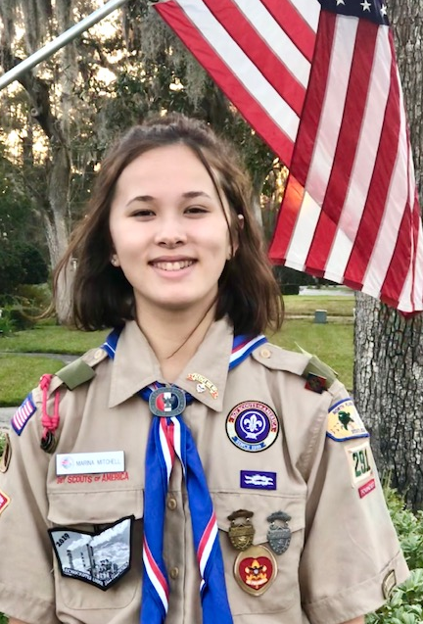

Eagle Court of honor

Program

**Opening Ceremony** …………………… Troop 288/ Troop 291

**Color Guard**.................................. Troop 291/ Troop 288

**Master of Ceremonies** ………………. Richard Basye

**Invocation** …………………………………. Father Matt

**Candle Ceremony** (Trail to Eagle)…….. Ed Turner

**Voice of the Eagle**………………………. Mike Munoz

**Guest Speaker**:…………………….……..Sheriff Rob Hardwick

**Four Winds/OA Ceremony**……….… Order of the Arrow

Presentation of Eagle Pin

Mentor Pin

**Eagle Charge**………………………………. Richard Basye

**Candidate’s Eagle Speech**………….. Marina Mitchell

**Candidate’s Eagle Speech**………….. Grant Mitchell

**Benediction**………………………....…... Father Matt

**Closing**…………………………………….…. Troop 291/ Troop 288

Please join us for a Fellowship Dinner after

.

**Marina Mitchell Troop 291**

**T R O O P 2 9 1**

**North Florida Council**

**PVUMC/Our Lady Star of the Sea**

**Ponte Vedra Beach, FL**

**Eagle Scout**

**Court of Honor**

**For Marina Mitchell**